Mastermind Instructions

Game Goal: Guess the Master Code; pure and simple. The code is either randomly generated or set by the “master” player during the game start-up. You strive only to survive as your guesses are dwindled towards zero.

Start Screen:

You get ten guesses to find the master code. When ready, press enter to begin game setup.

Playing solo or do you have friends? Press 1 or 2, while making sure the number replaces the 0 in the box, and then press enter.

Note: If playing one player our next setting is difficulty which you can read about in the Game Difficulty section for more information or curious. After entering your choice, press enter.

After the difficulty selection game boxes appear, so shall a box for your current attempt number. The box containing “Box Number” displays what box you’re currently on, by row, starting from the left.

The game has officially has now officially begun.

Game Difficulty: *6* *levels*.  
1: Normal

2: Intermediate

3: Advanced

4: Pro

5: Master

6: Insane

Each difficulty level adds another number / color to the master code combination set size.

Difficulty 1 – Normal for example (level 1), has numbers 0, 1, 2, 3, 4 while difficulty 6 – insane has numbers 0, 1, 2, 3, 4, 5, 6, 7, 8, 9.

Game Checking:

The game checks your input after the last box has been entered. There are three responses you can be rewarded with.   
 After the first row, a box to the left of the guess boxes will appear, and display the results of your guesses.

A ‘Y’ means you have guessed a correct number, and it’s in the correct spot.

A ‘C’ means you have guessed a correct number however it’s in an incorrect position.

An ‘X’ means you have neither a correct number, nor position.

Example:

X

C

Y

X

This example shows that a player guess contains two incorrect guesses ‘X’ ‘s, with one guess correct, and the other a correct number.

Troubleshooting issues:

When pressing a button, it may not show up as a color/ shows up black. Try pressing a different button/color then the button you wanted. (6 is just a really light blue)

Box Colors:

1. Red
2. Green
3. Blue
4. Orange
5. Purple
6. Light Blue
7. Pink
8. Yellow/Gold
9. Dark Green
10. Grey

Extra:

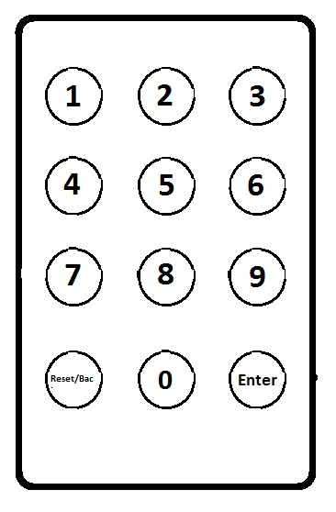At start-up, logo is displayed, and game is “drawn”.

The logo color and head box color are always random once the program begins, thanks to a thermo sensor.

|  |  |  |  |  |  |  |  |
| --- | --- | --- | --- | --- | --- | --- | --- |
|  |  |  |  |  |  |  |  |
|  |  |  |  |  |  |  |  |
|  |  |  |  |  |  |  |  |
|  |  |  |  |  |  |  |  |
|  |  |  |  |  |  |  |  |
|  |  |  |  |  |  |  |  |
|  |  |  |  |  |  |  |  |
|  |  |  |  |  |  |  |  |
|  |  |  |  |  |  |  |  |
|  |  |  |  |  |  |  |  |